**MYSQL Assignment_1**

/\***1.**create a database named company and a table named employees with the following fields:

* Id(INT,Primary key,Auto increment)
* Name(VARCHAR(100))
* Position(VARCHAR(100))
* Salary(DECIMAL(10,2))
* Date_ of_ joining(DATE)*/

**Create database company;**

**Use company;**

**Create table employees(**

**Id int primary key auto_increment,**

**Name varchar(100),**

**Position varchar(100),**

**Salary decimal(10,2),**

**Date_of_joining date);**

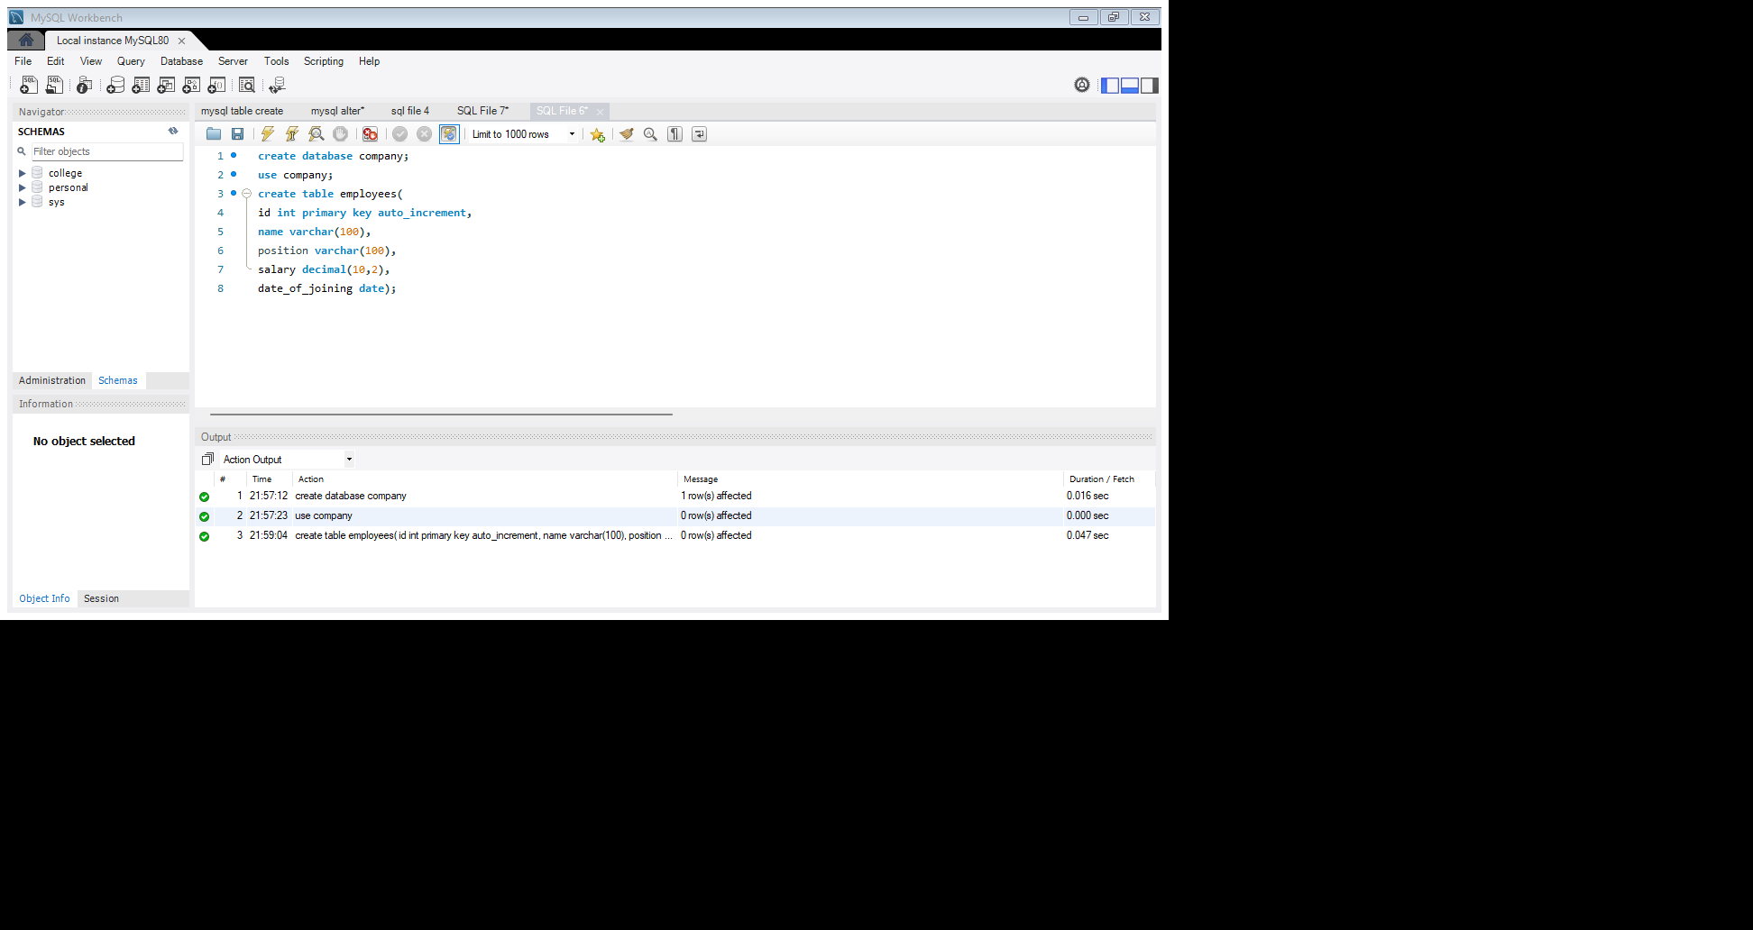

/\***2.**Insert the following data into the employees table:

* John Doe,Manager,55000.00,2020-01-15
* Jane Smith,Developer,48000.00,2019-07-10
* Alice Johnson,Designer,45000.00,2021-03-22
* Bob Brown,Developer,50000.00,2018-11-01*/

**Insert into employees(name,position,salary,date_of_joining)**

**values("John Doe","manager",55000.00,"2020-01-15"),**

**("Jane Smith","Developer",48000.00,"2019-07-10"),**

**("Alice Johnson","Designer",45000.00,"2021-03-22"),**

**("Bob Brown","Developer",50000.00,"2018-11-01");**

**Select*from employees;**

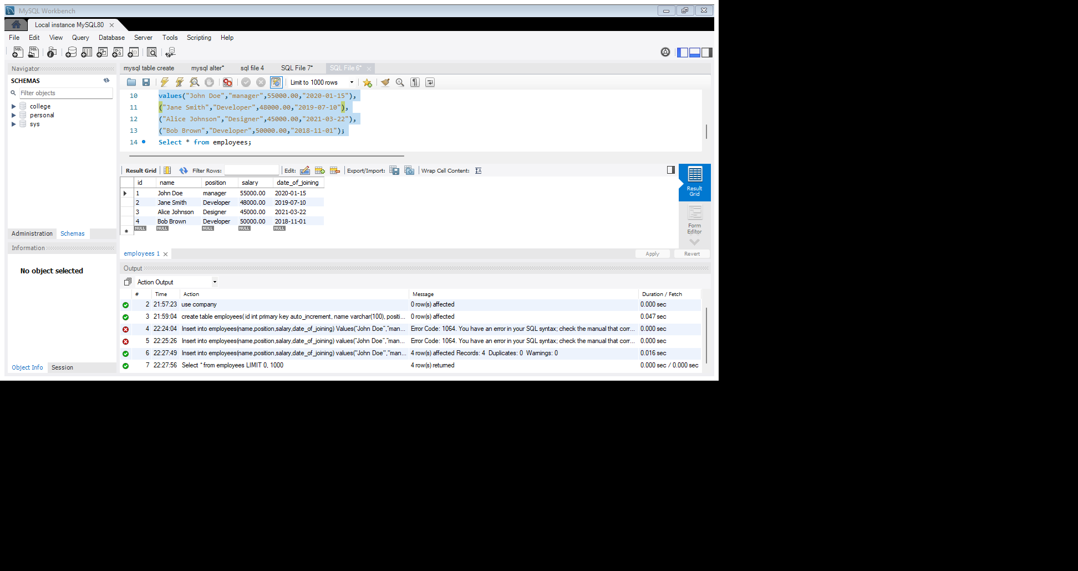



**/*3.**Write a query to retrieve all employees who are Developers.*/

**select * from employees where position="Developer";**

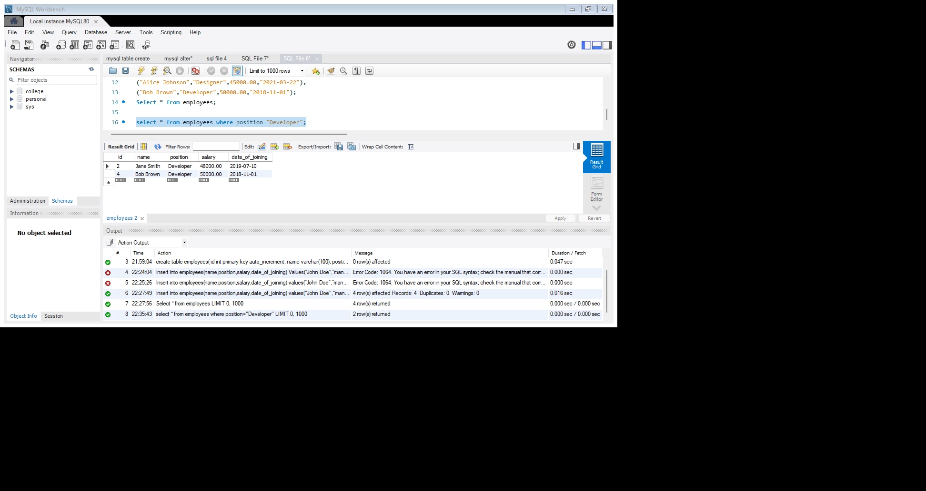



/\***4.**Write a query to update the salary of Alice Johnson to 46000.00.*/

**set sql_safe_updates=0;**

**Update employees**

**set salary=46000.00 where name ="Alice Johnson";**

**select*from employees;**

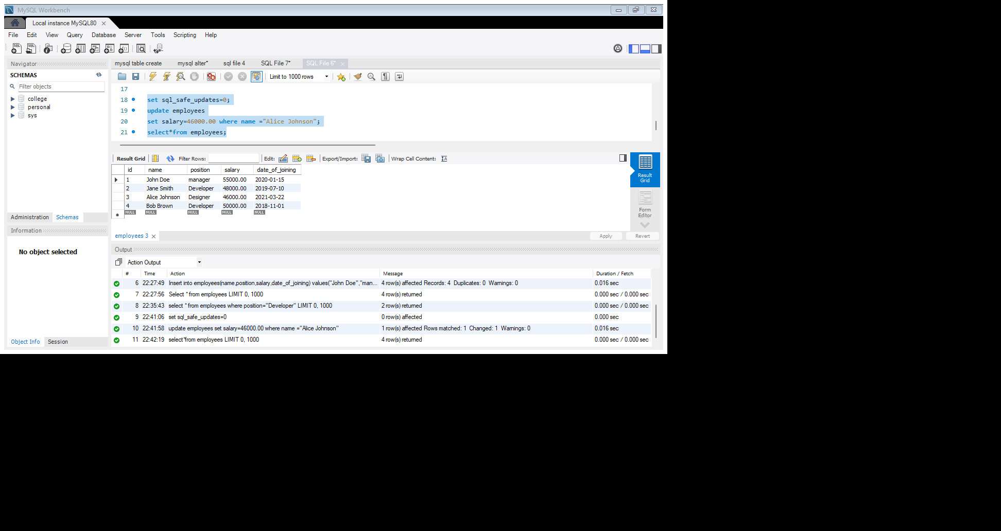



/\***5.**.Write a query to delete the employee record for Bob Brown.*/

**delete from employees where name="Bob Brown";**

**select * from employees;**

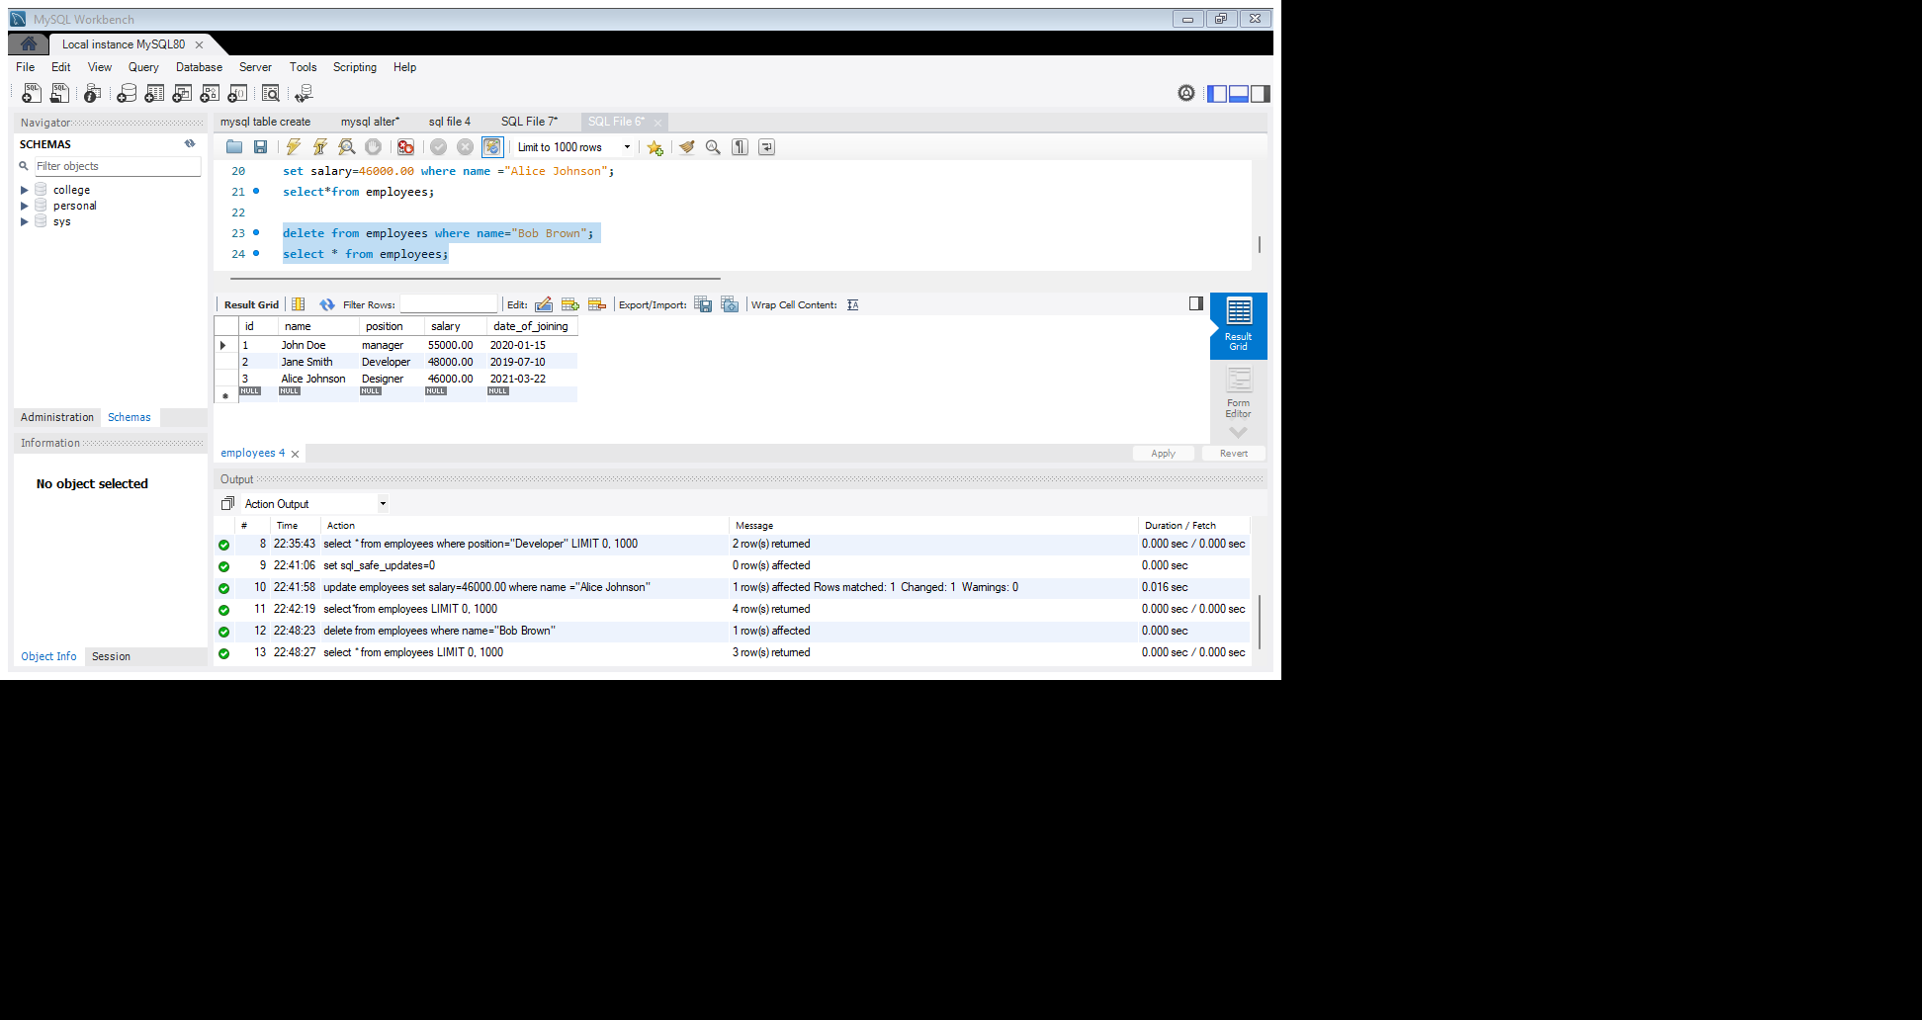



/\***6.**Write a query to find the employees who have a salary greater than 48000.*/

**select name from employees where salary>48000;**

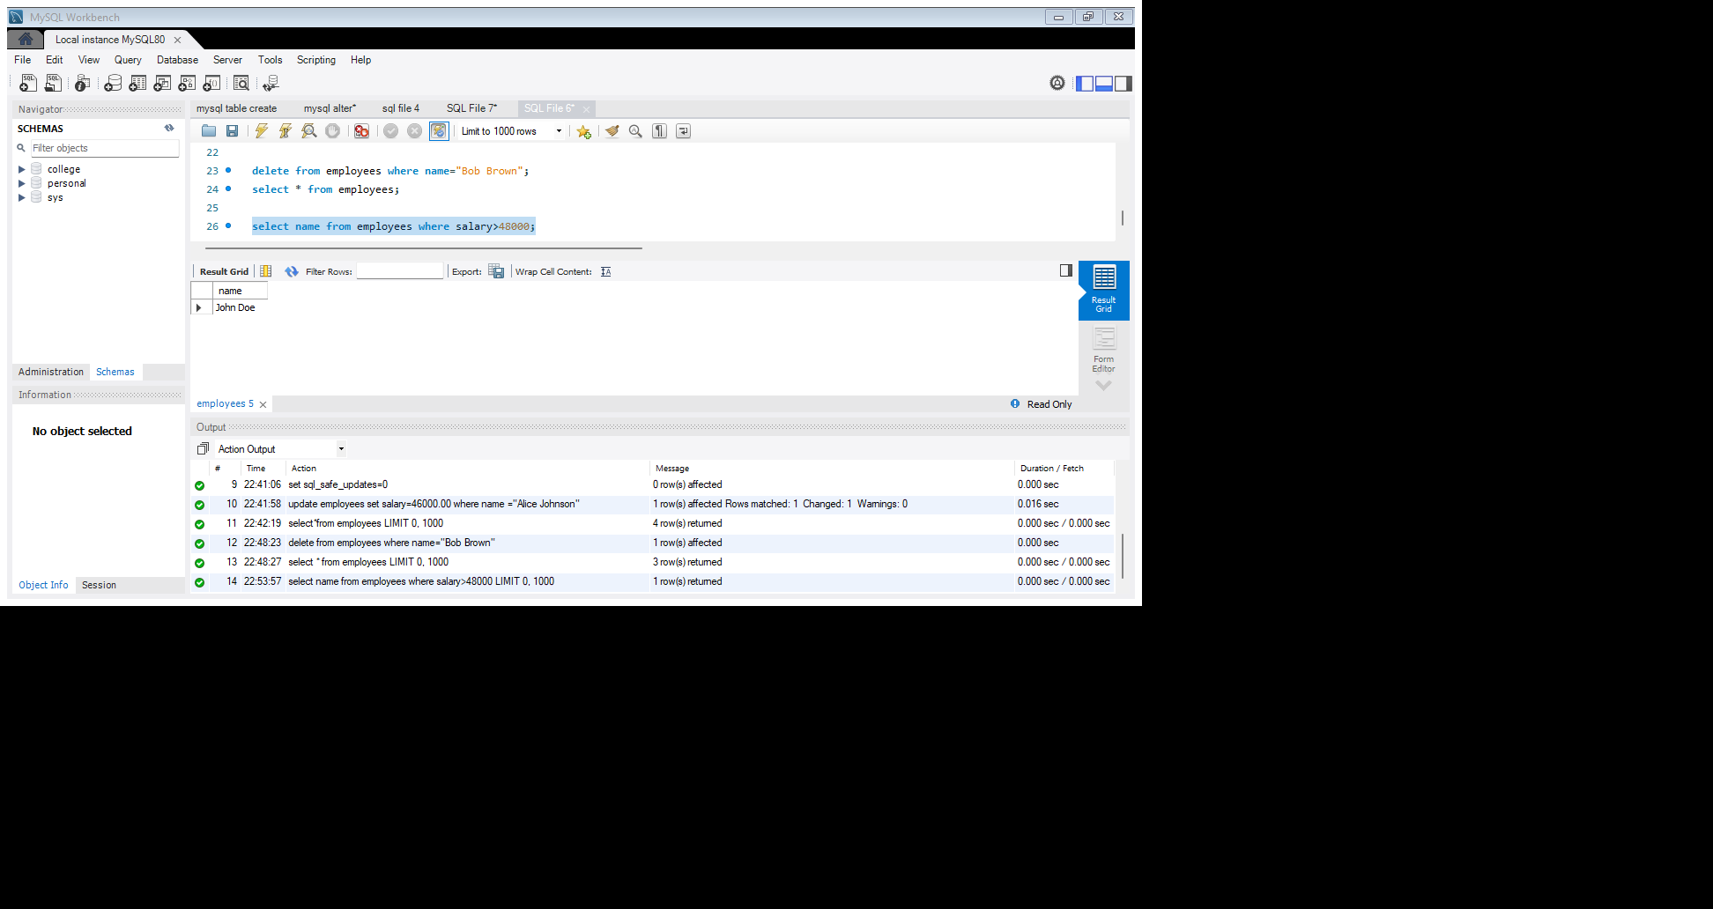



/\***7.**Write a query to add a new column email to the employees table.*/

**alter table employees**

**add email varchar(20);**

**select * from employees;**

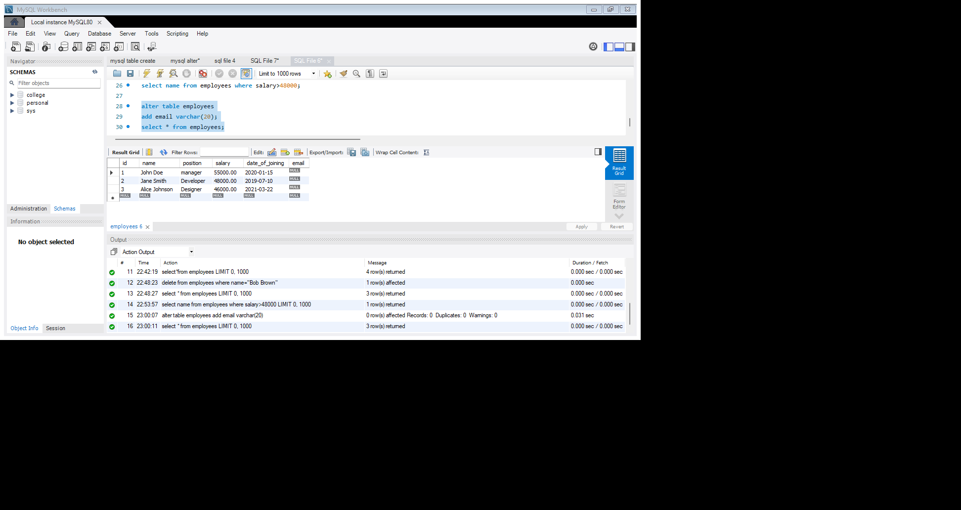



*/**8.**Write a query to update the email for John Doe to [john.deo@company.com*/](mailto:john.deo@company.com*/)

**set email="john.doe@company.com"where name ="John Doe";**

**select*from employees;**

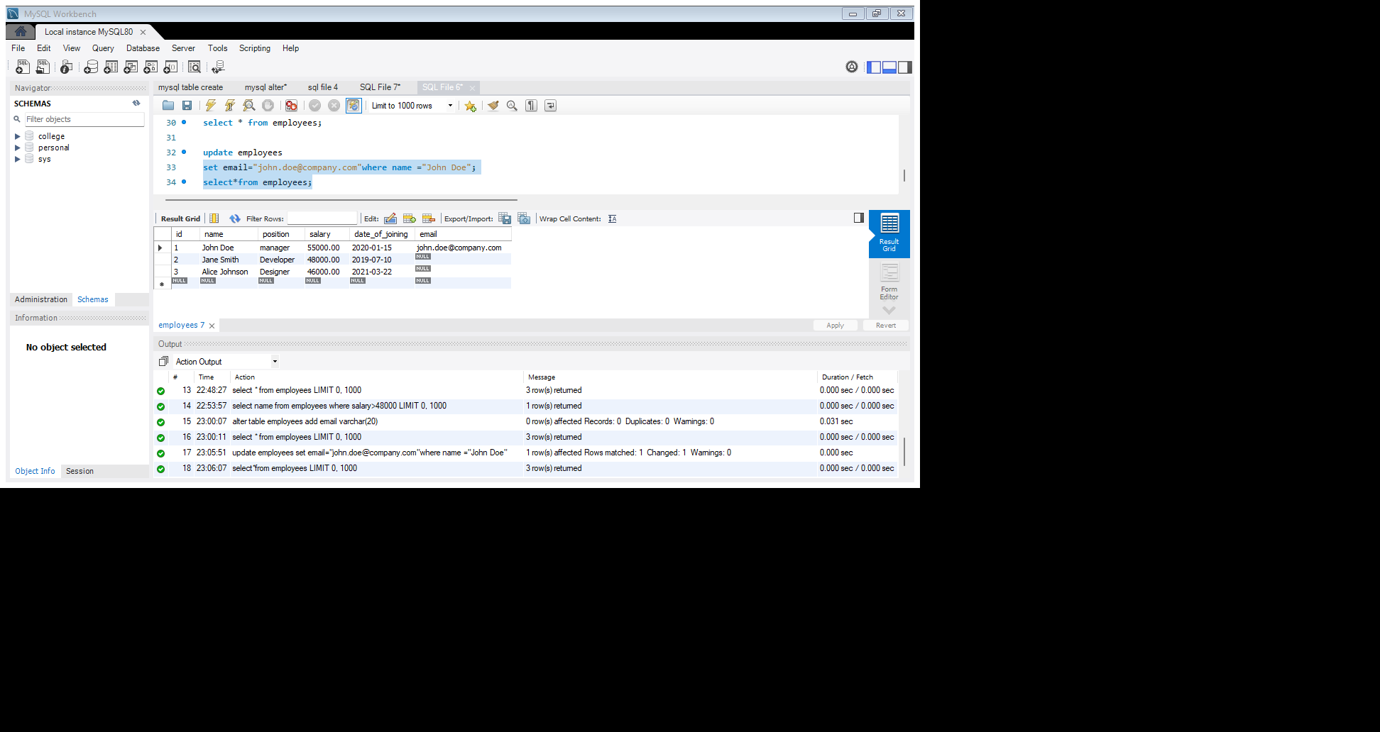



/\***9.**Write a query to retrieve only the name and salary of all employees.*/

**select name,salary from employees;**

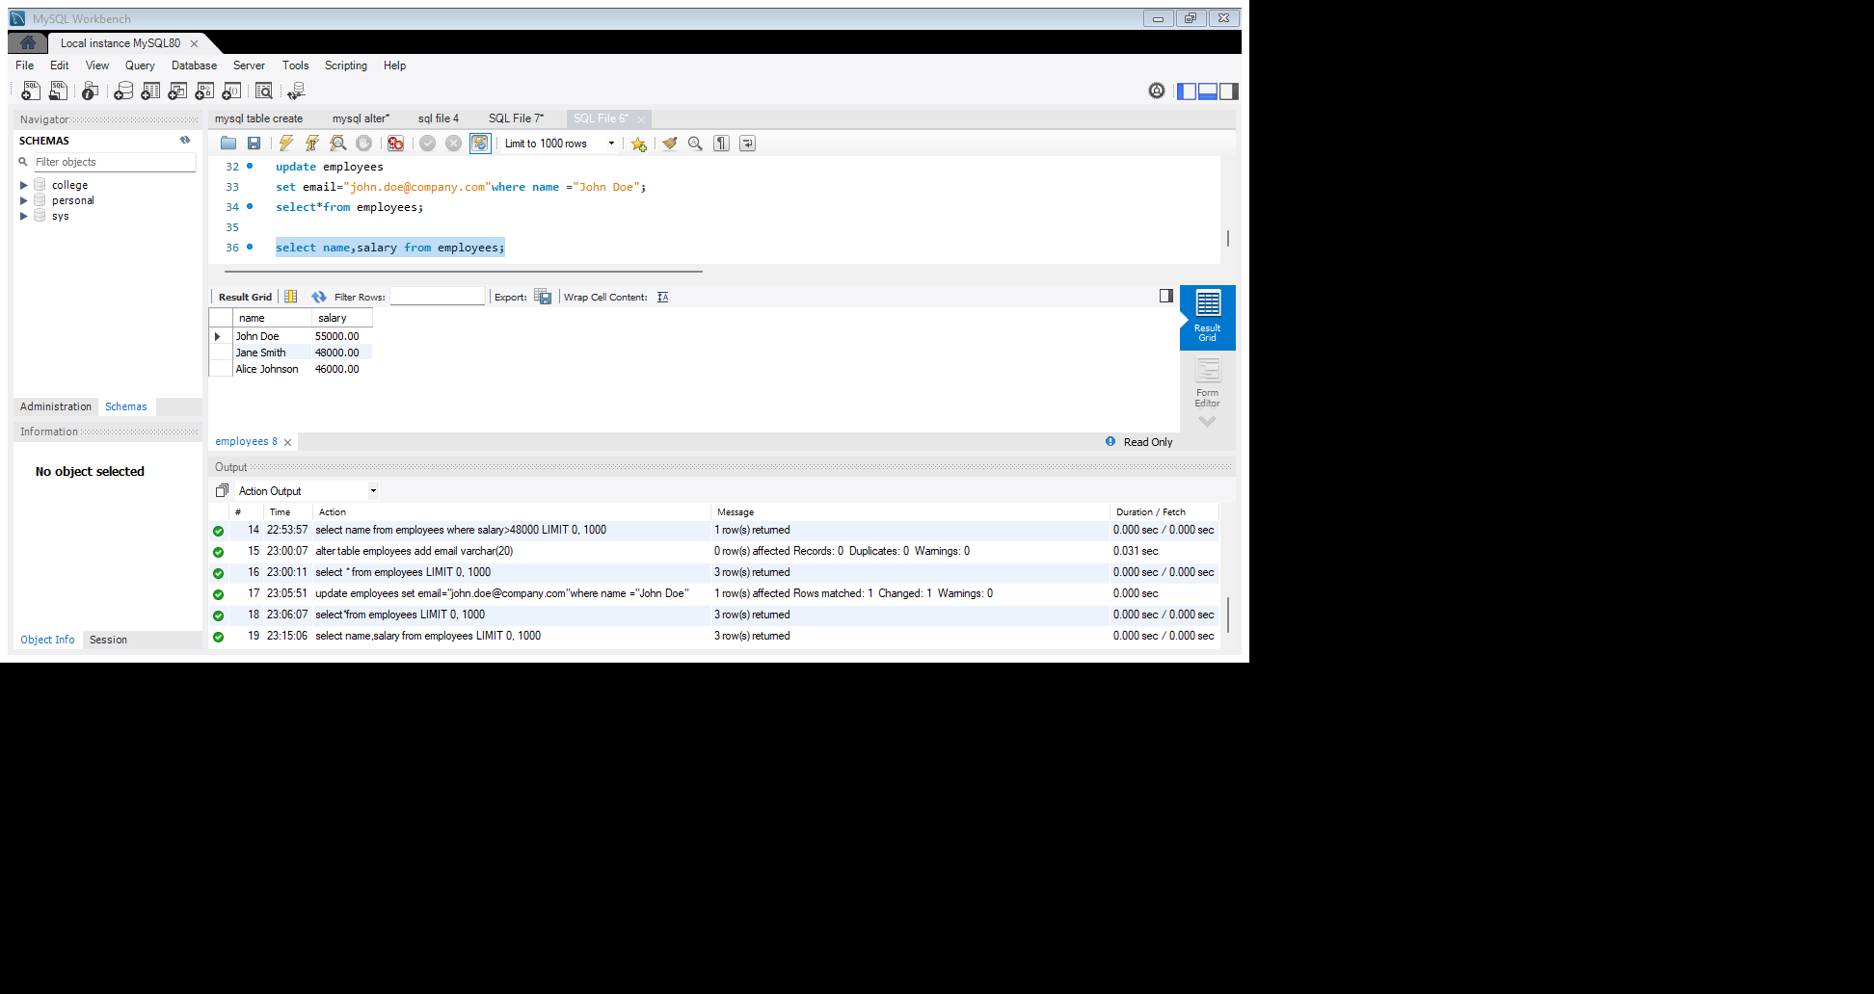



/\***10.**Write a query to count the number of employees who joined after January 1, 2020.*/

**select count(date_of_joining)from employees where date_of_joining>"2020-01-01";**

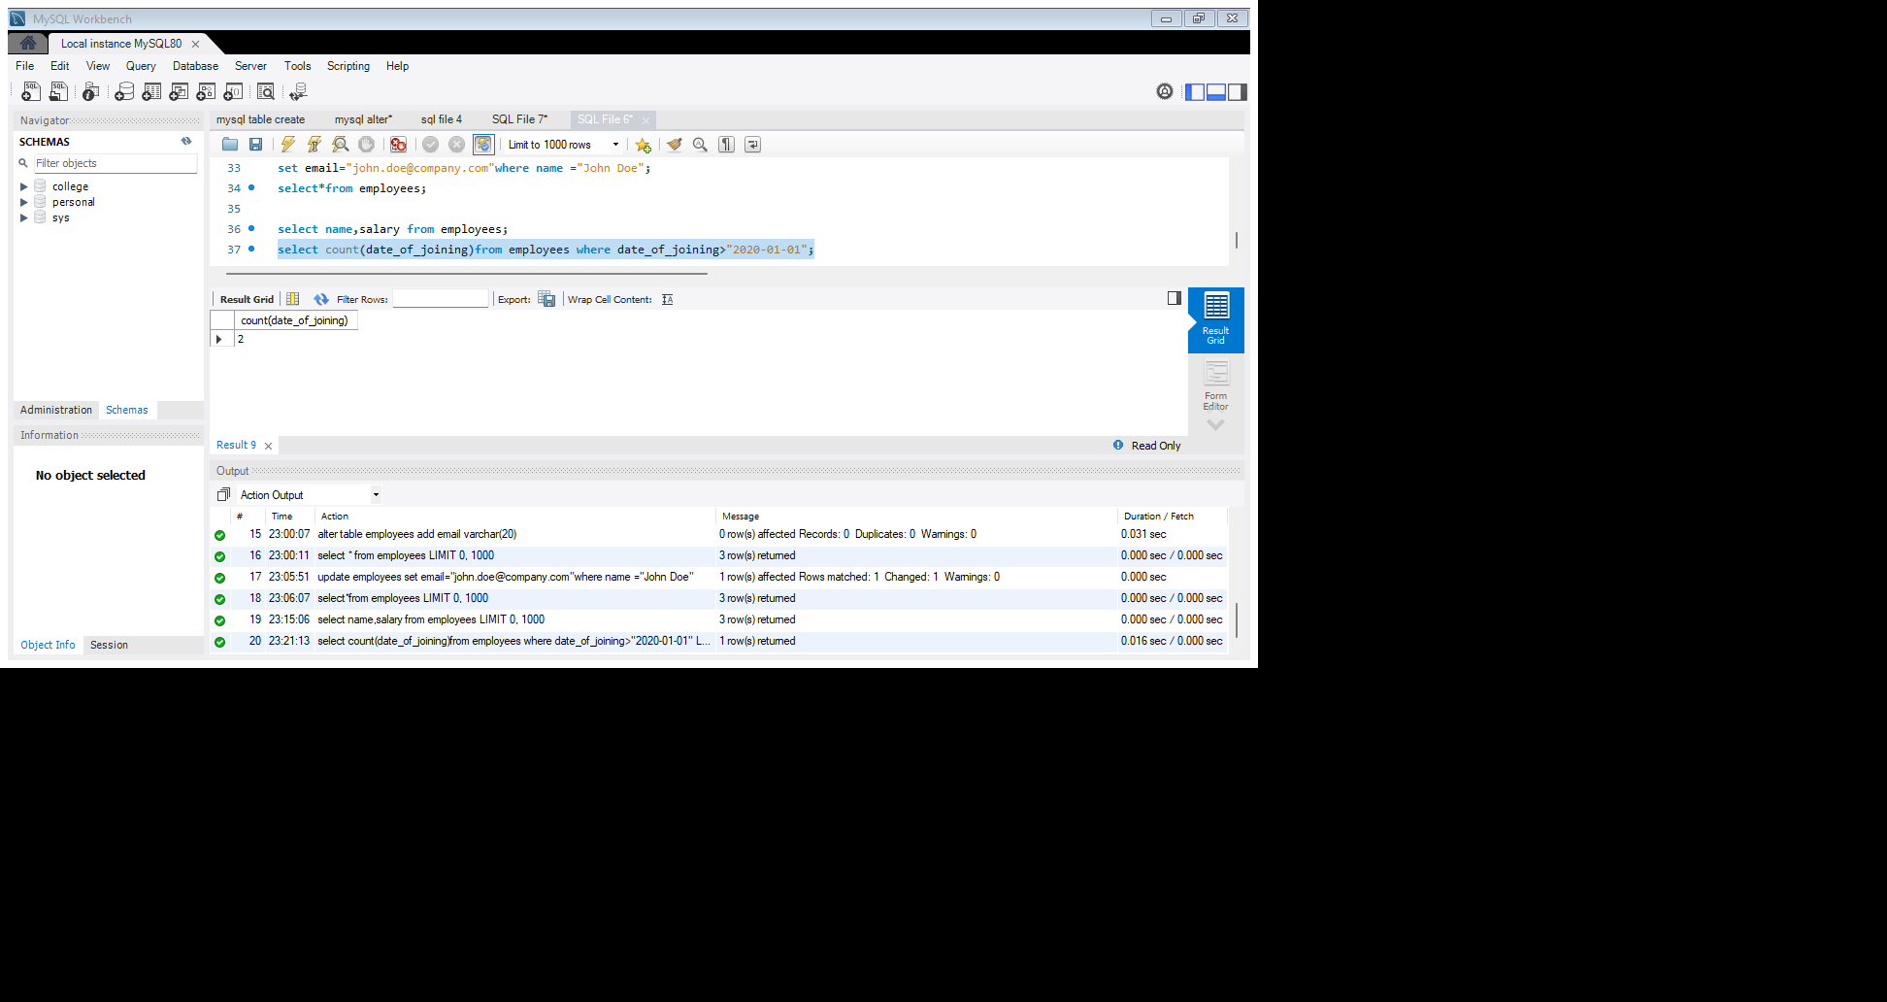



/\***11.**Write a query to order the employees by salary in descending order.*/

**select * from employees order by salary desc;**

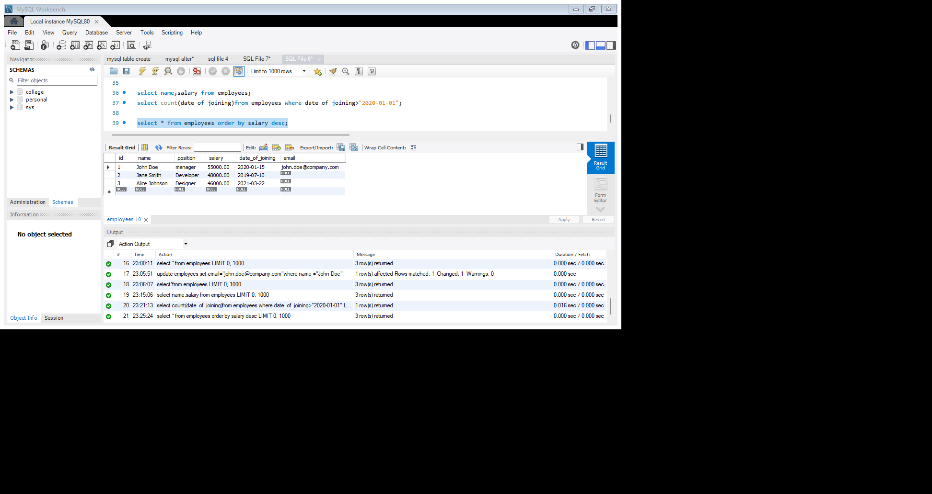



/\***12.**Write a query to drop the email column from the employees table,*/

**alter table employees**

**drop email;**

**select *from employees;**

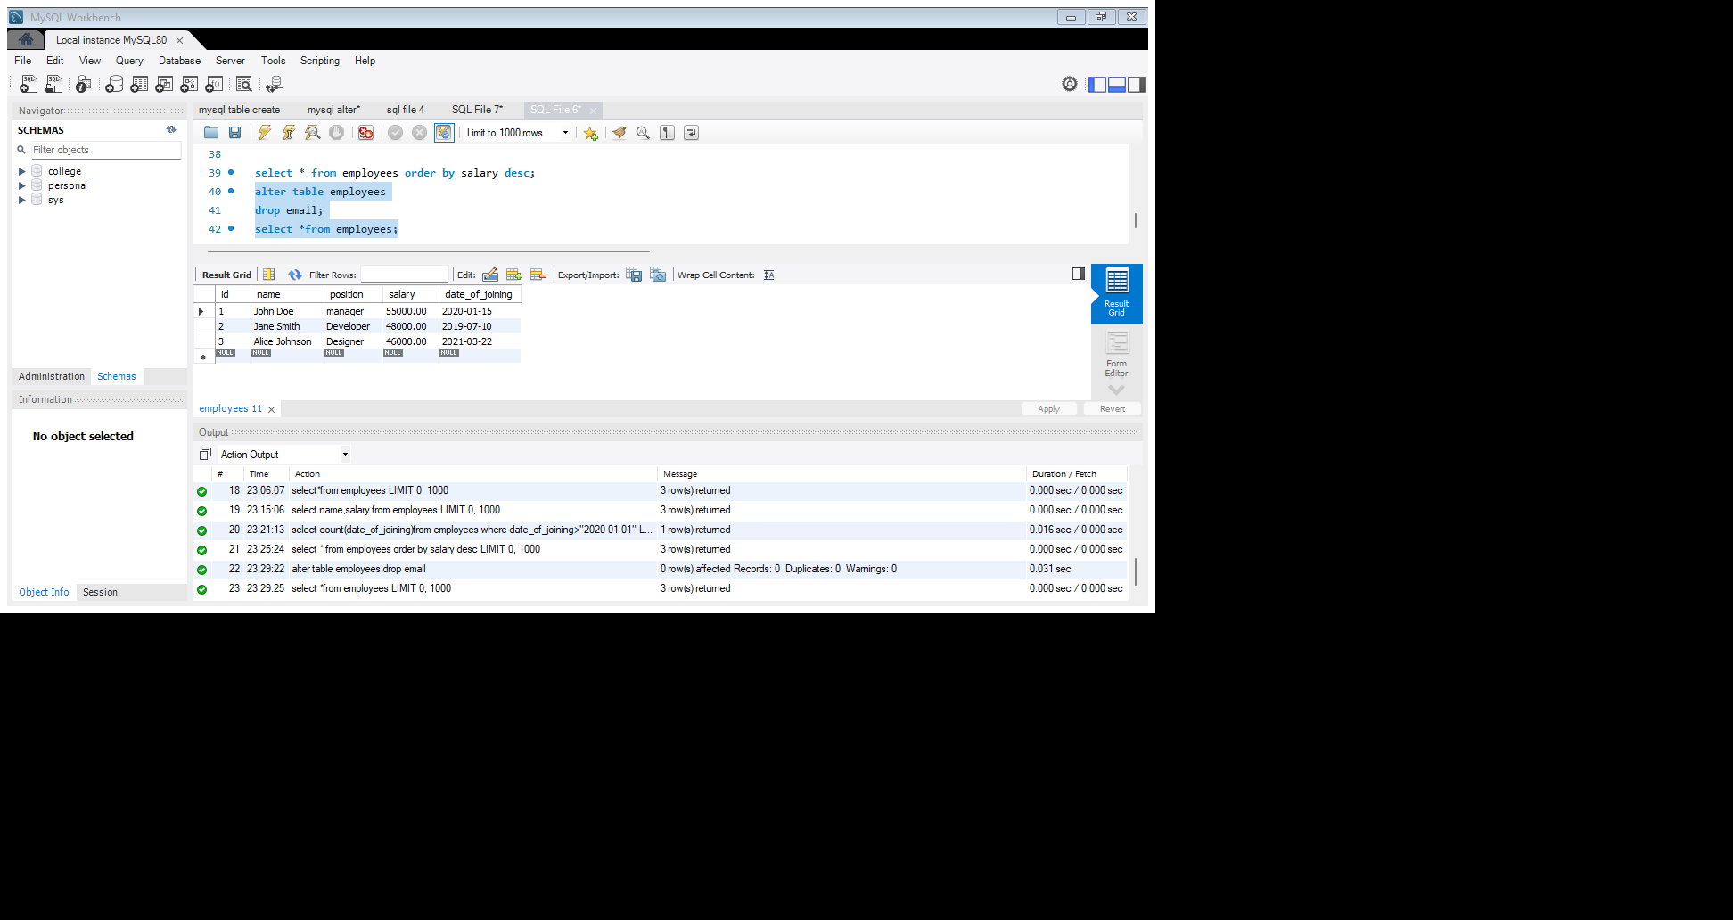



/\***13.**Write a query to find the employee with the higher salary.*/

**select name from employees order by salary desc limit 1;**



